Art Project Ideas:
~Paint/Draw a picture of a favorite character
~Paint/Draw an alternate cover for the book
~Make a collage of how the book makes you feel
~Draw, color/paint, build your favorite part or scene from the book

Artwork must be mounted or matted on sturdy material and not exceed 11”x14” with mat.
3D artwork must be light enough to carry and smaller than 2’x2’x2’.
Projects must be by an individual student.
Each entry must include a Reader’s Statement which tells how the piece was inspired by one of the Florida award nominated books.

Digital Project Ideas:

~Book Trailer summarizing the book
~Powerpoint about a character, scene from the book, favorite part, etc.
~Video of you acting out a favorite scene
~Project must be 1 minute or less and include both sound and video.
~Projects can be done by an individual student, or a group of 2 or 3 students.

Projects are due to Mrs. French by January 17th and will be on display in the Media Center!

Taste of SLAM
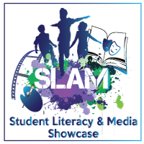

A Menu of Tasty
Book Treats!

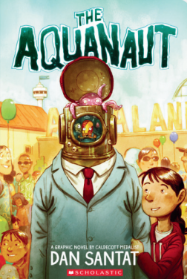   | 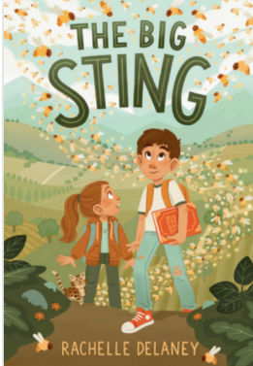 |  | 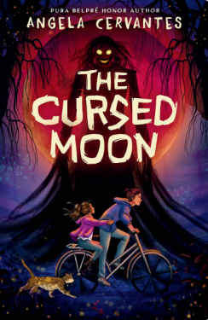 | 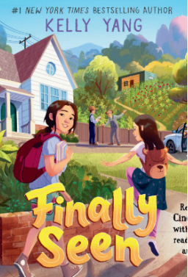
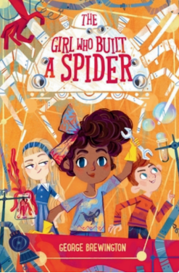 | 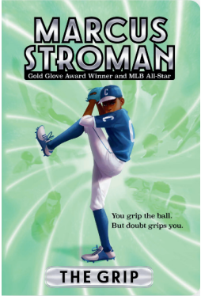 | 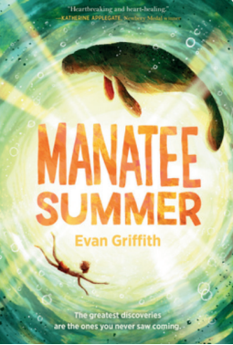 | 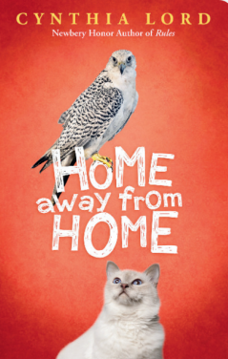 | 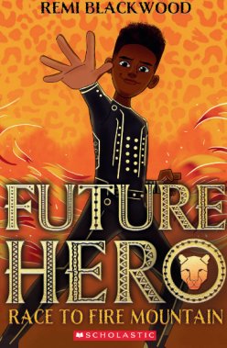
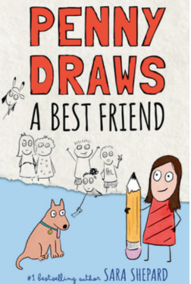 | 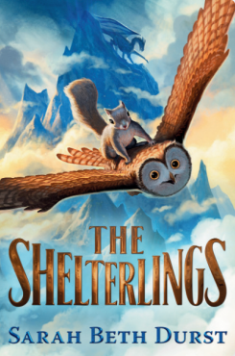 | 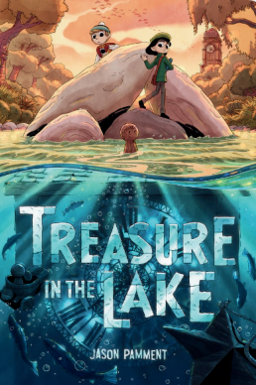 | 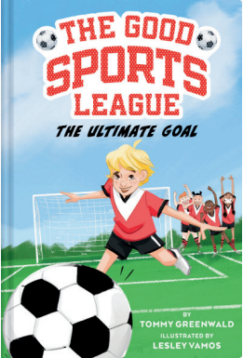 | 